Project Documentation
Prepared using the supplied 'FSD Documentation Format' (written for MERN projects). Its 13 sections are kept in the same order and interpreted for the ServiceNow platform; sections that do not apply are marked as such.

1. Introduction
Project Title: Automated Network Request Management in ServiceNow
Team Members: [Team Leader / Team Members — names and roles]
GitHub Repository: https://github.com/pavan-kalyan-pk-2646/servicenow-network-request-automation.git
Project Demo (Drive folder): https://drive.google.com/drive/folders/1PAaBuybnLuN8JptoJ27fXBuDrTUFdcjM?usp=sharing
Name | Role
[Name] | [e.g. Team Lead / ServiceNow Developer]
[Name] | [e.g. Tester / Documentation]

2. Project Overview
Purpose: provide a structured, automated way to request, record, approve and fulfil network services in ServiceNow, replacing manual phone and email handling.
Features:
- Network Request catalog item (Network category, 'Network Services Request') with seven variables, six of them mandatory.
- 'Requester Information' variable set (Opened on behalf of, Email, User Name, Phone Number).
- UI Policy 'Show existing ID field' — the existing-ID field appears only for Existing connections.
- Custom table Database Tables (u_database_table) with DAT-numbered records and an Approval Status.
- Flow 'Network Request Automation' with a Service Catalog trigger: Get Catalog Variables → Create Record → Send Email → Ask For Approval → If Request is Approved → Update Record (then / Else).
- 'Approval Request' relationship listing approvals for each record.
- Outbound email notification record (delivery requires SMTP — not configured).
- Catalog task closure by the Network Team.

3. Architecture
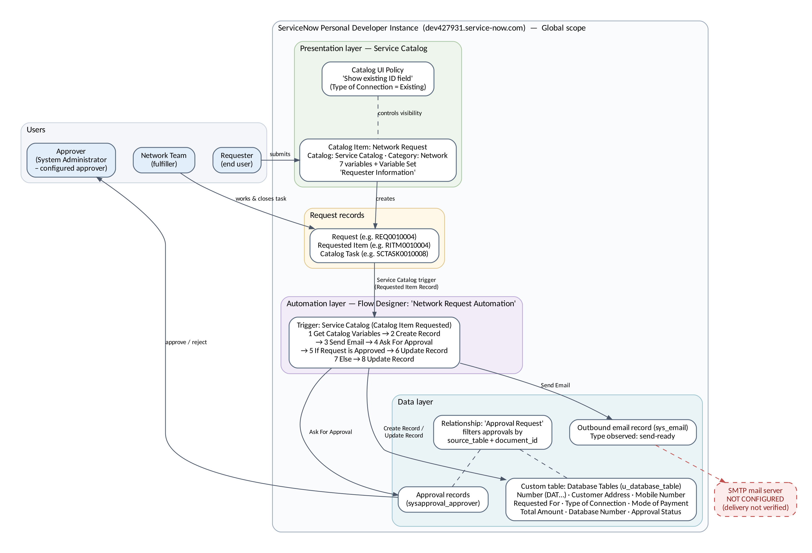
Figure 1: Architecture overview
Frontend (MERN: React) → ServiceNow Service Catalog / Service Portal. The user interface is the Network Request catalog item form rendered by ServiceNow. Client-side behaviour comes from the Catalog UI Policy (Screenshot 4). No custom front-end code was written.
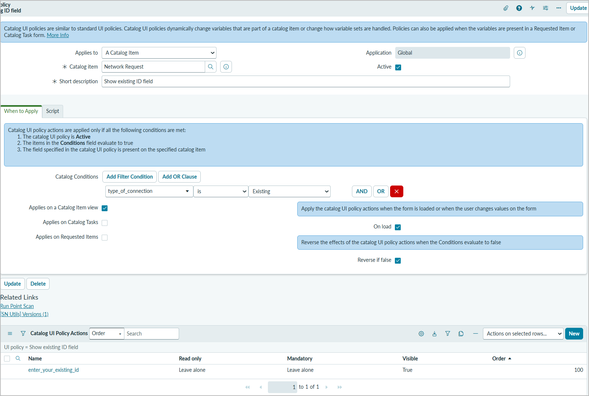
Screenshot 4: Catalog UI Policy 'Show existing ID field' — condition type_of_connection is Existing; On load and Reverse if false enabled; action Visible = True
Backend (MERN: Node.js/Express) → Flow Designer. Business logic runs in the flow 'Network Request Automation' (Global scope, Service Catalog trigger), using the approval engine (Ask For Approval) and the email subsystem (Send Email).
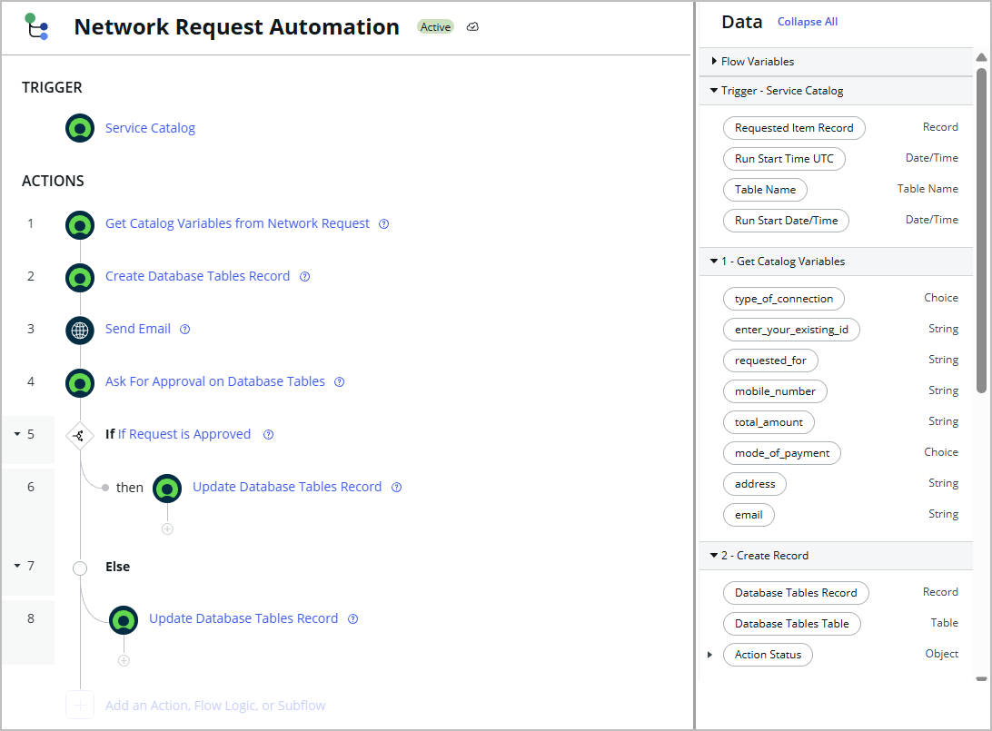
Screenshot 6: Flow 'Network Request Automation' (Active, Global) — Service Catalog trigger, actions 1–8 and data pills (empty middle area of the screen removed)
Table 1: Flow steps
Step | Action | Purpose | Inputs, outputs and test-run result
Trigger | Service Catalog (execution label: Catalog Item Requested) | Starts the flow when the Network Request catalog item is requested. | Outputs: Requested Item Record, Table Name, Run Start Time UTC, Run Start Date/Time.
1 | Get Catalog Variables from Network Request | Reads the variables submitted on the requested item. | Input: Requested Item Record (trigger). Outputs: type_of_connection (Choice), enter_your_existing_id, requested_for, mobile_number, total_amount, mode_of_payment (Choice), address, email. Test run: Completed, 98 ms.
2 | Create Database Tables Record | Creates the Database Tables record that represents the request. | Fields populated: Customer Address, Mobile Number, Mode of Payment, Requested For, Total Amount, Type of Connection, Database Number, Approval Status. Output: Database Tables Record. Test run: Completed, 152 ms. Defect BG-03: stored values are variable names, not submitted values.
3 | Send Email | Generates the acknowledgement email with subject 'Network Request Received - Pending Approval'. | Email record target: the Database Tables record (observed: DAT0001016). Test run: Completed, 925 ms. Delivery depends on SMTP (not configured).
4 | Ask For Approval on Database Tables | Requests approval of the network request. | Approval Field: Approval Status; Reason: Network request approval; Rule: Approve when anyone approves; Approver: System Administrator (as reported by the project owner; the step configuration is not visible in the screenshots). Test run: Completed (action start 21:55:27).
5 | If Request is Approved | Evaluates the approval outcome. | Test run: Evaluated — True at 21:58:24 (288 ms).
6 | Update Database Tables Record (then) | Approved branch: sets Approval Status to Approved. | Test run: Completed (288 ms).
7 | Else | Branch taken when the request is not approved. | Test run: Not Run.
8 | Update Database Tables Record (Else) | Rejected branch: updates Approval Status for a rejected request. | Test run: Not Run — rejected path not yet tested.

Database (MERN: MongoDB) → ServiceNow tables. Data is stored in platform tables: the custom table u_database_table (Screenshot 5) plus the standard request, requested item, catalog task, approval and email tables. The 'Approval Request' relationship links approvals to a record using source_table and document_id.
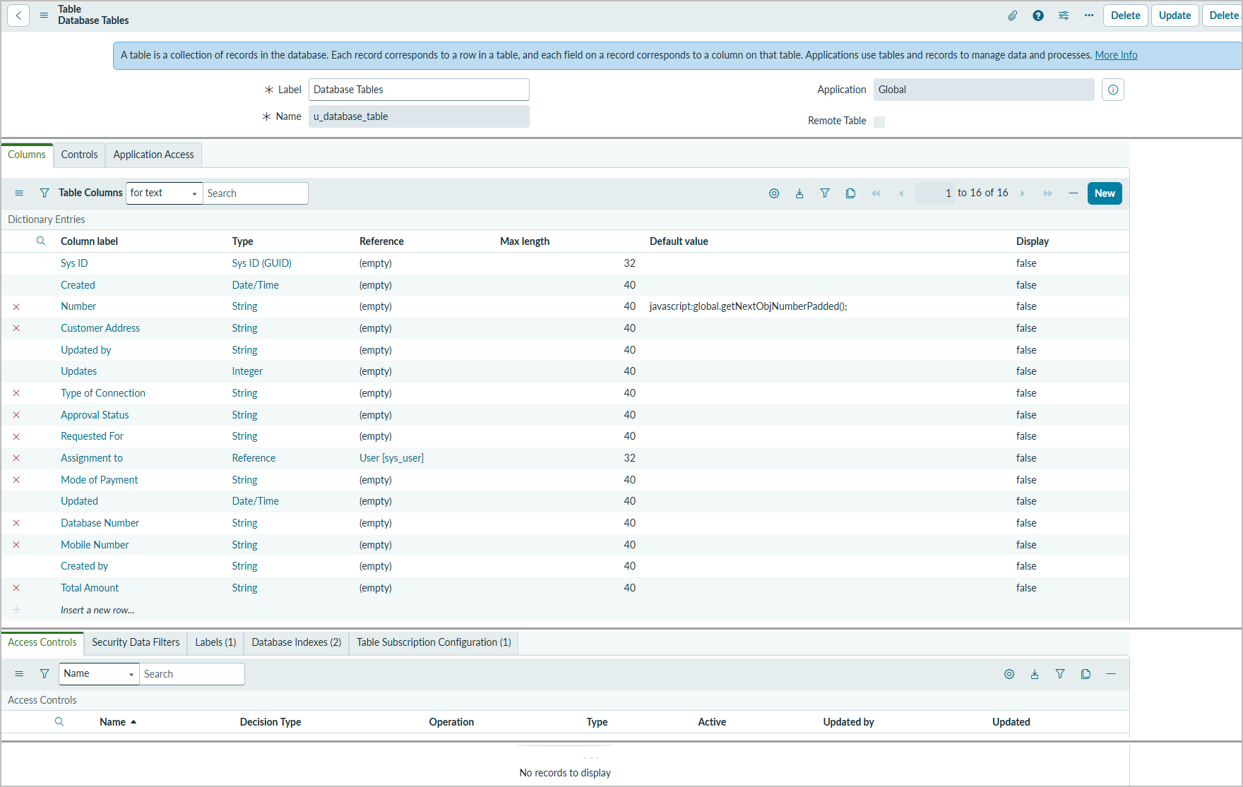
Screenshot 5: Table definition Database Tables (u_database_table) — 16 columns; Access Controls list empty
Table 2: u_database_table columns
Column | Type | Reference | Notes
Number | String | — | Default javascript:global.getNextObjNumberPadded() → DAT numbers (e.g. DAT0001016)
Database Number | String | — | Custom field; populated by Create Record
Customer Address | String | — | Populated by Create Record
Mobile Number | String | — | Populated by Create Record
Requested For | String | — | Populated by Create Record
Type of Connection | String | — | Populated by Create Record
Mode of Payment | String | — | Populated by Create Record
Total Amount | String | — | Populated by Create Record
Approval Status | String | — | Approval Field of Ask For Approval; values observed: Pending, Approved, requested
Assignment to | Reference | User [sys_user] | Empty in all observed records
System fields | Sys ID, Created, Created by, Updated, Updated by, Updates | — | Standard ServiceNow columns

4. Setup Instructions
Prerequisites: a ServiceNow instance (a Personal Developer Instance was used), an account with the admin role, Flow Designer / Workflow Studio, and — for real email delivery — an active SMTP email account. No Node.js or MongoDB is needed.
Installation (re-creating the configuration):
1. Create the custom table Database Tables (u_database_table) with the columns listed in Section 3 (Number with default javascript:global.getNextObjNumberPadded()).
2. Create the Relationship 'Approval Request' with the refineQuery script (Appendix) and add the related list to the Database Tables form.
3. Create the catalog item 'Network Request' in category Network, short description 'Network Services Request'.
4. Add the variables Requested For, Mobile Number, Type of Connection (New, Existing), Enter your existing id, Total Amount, Mode of Payment (UPI, CARD) and Address; mark all except the existing id as mandatory.
5. Attach the variable set 'Requester Information' (Opened on behalf of, Email, User Name, Phone Number).
6. Create the Catalog UI Policy 'Show existing ID field': condition type_of_connection is Existing; Applies on a Catalog Item view; On load; Reverse if false; action enter_your_existing_id Visible = True.
7. Create the flow 'Network Request Automation' with a Service Catalog trigger and the actions in Section 3. In Create Record, map every field with data pills from Get Catalog Variables (see Known Issues). Activate the flow and make sure requesting the item runs it (for example, through the catalog item's process engine flow setting).
8. Define ACLs for u_database_table.
9. For delivery, configure and test an outbound SMTP email account.
10. Run the test cases in Section 10.
Environment variables: not applicable. Instance-specific values (SMTP account, approver) are configured in the instance and are not stored in the repository.

5. Folder Structure
ServiceNow has no project folders; the application consists of configuration records. Their logical structure is shown below, followed by a suggested layout for the GitHub repository (https://github.com/pavan-kalyan-pk-2646/servicenow-network-request-automation.git). On 2026-10-20 the GitHub repository was publicly reachable and contained only README.md; the contents of the demo Drive folder could not be viewed by the documentation author and are not verified here.
Area (MERN equivalent) | ServiceNow configuration records
Client | Catalog item Network Request; variables; variable set Requester Information; Catalog UI Policy Show existing ID field
Server | Flow Network Request Automation; relationship Approval Request (script)
Data | Table u_database_table and its columns; approval, request, task and email records

repository/
├── README.md (already in the repository)
├── docs/ (phase documents, project report — PDF and DOCX)
├── screenshots/ (Screenshot 1–10, recipient redacted)
├── diagrams/ (PNG + editable .dot sources)
├── servicenow/
│ └── approval_request_relationship.js
└── demo/ (link to the explanation video)

6. Running the Application
1. Log in to https://dev427931.service-now.com.
2. Open the Service Portal / Service Catalog → Network → Network Request.
3. Fill the form (choose New or Existing) and click Order Now.
4. Open Workflow Studio → Network Request Automation → Executions to follow the run.
5. Approve the request as the configured approver.
6. Open the Database Tables list and check Approval Status.
7. Work and close the catalog task.
8. Check System Logs → Emails for the notification record.
The MERN commands 'npm start' (client/server) are not applicable.

7. API Documentation
Not applicable — no custom REST or scripted APIs were built. The solution uses ServiceNow's internal Flow Designer actions. Standard platform APIs (such as the Table API) exist but were not used or tested in this project.

8. Authentication
Users sign in with ServiceNow accounts; authorisation follows ServiceNow roles. Tests used the System Administrator account, which is also the configured approver. No custom tokens or sessions are implemented. No ACLs are listed for u_database_table (BG-04). No credentials are stored in this documentation or the repository.

9. User Interface
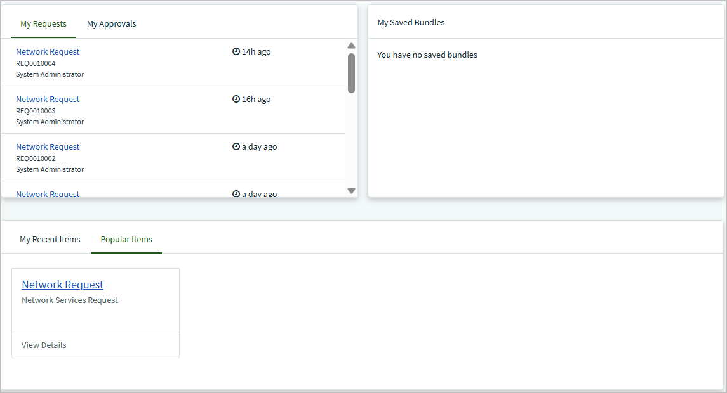
Screenshot 1: Service Portal — Network Request in Popular Items ('Network Services Request') and My Requests listing REQ0010004, REQ0010003 and REQ0010002
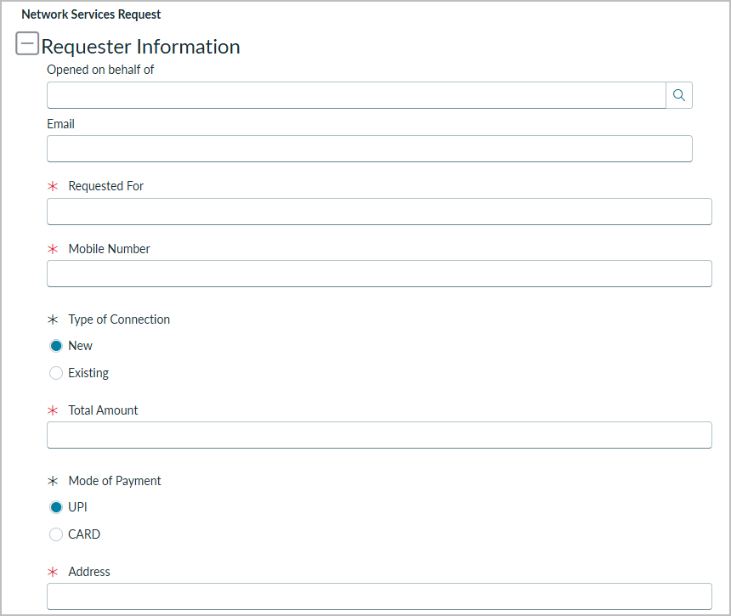
Screenshot 2: Network Request form with Type of Connection = New — 'Enter your existing id' is hidden
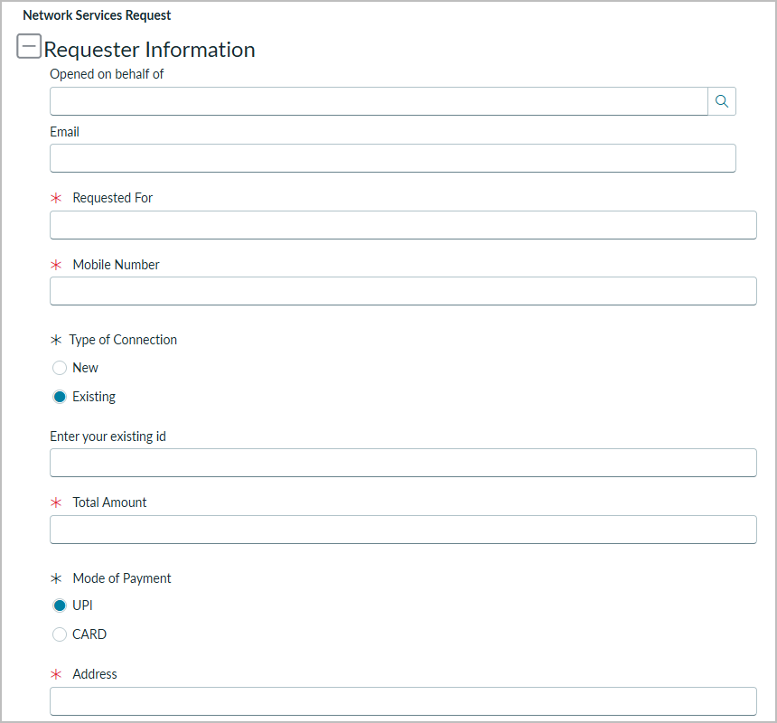
Screenshot 3: Network Request form with Type of Connection = Existing — 'Enter your existing id' is visible; mandatory variables marked *

10. Testing
Strategy: manual functional testing on the developer instance, with evidence from records, configuration pages and flow executions. 24 test cases — Pass 11, Fail 1, Requires Verification 4, Not Tested 8. Tools: Workflow Studio execution details, list and form views, System Logs → Emails.
Table 3: Test case summary
ID | Scenario | Expected Result | Actual Result | Status | Evidence
TC-01 | Catalog item availability | Item available with description 'Network Services Request'; form opens. | Network Request shown in Popular Items with 'Network Services Request'; form opens at Network > Network Request. | Pass | Screenshots 1, 3
TC-02 | Request submission | Request record generated with a request number. | My Requests lists REQ0010004, REQ0010003 and REQ0010002 for Network Request. | Pass | Screenshot 1
TC-03 | Existing-ID field shown for Existing | 'Enter your existing id' becomes visible. | Field visible when Existing is selected. | Pass | Screenshots 3, 4
TC-04 | Existing-ID field hidden for New | 'Enter your existing id' is not shown. | Field not shown when New is selected. | Pass | Screenshot 2
TC-05 | Variable set: Email and User Name auto-population | Email and User Name are populated from the referenced user. | Reported as populated by the tester; no screenshot captured (Screenshots 2 and 3 show the fields before a user is selected). | Requires Verification | Tester observation only
TC-06 | Variable set: Phone Number auto-population | Phone Number is populated when the user record holds a phone value. | Phone Number did not populate for the System Administrator account. | Requires Verification | BG-01
TC-07 | Flow trigger on catalog item request | Flow starts on the Service Catalog trigger. | Trigger 'Service Catalog'; execution shows 'Catalog Item Requested' (Test Run — Completed). | Pass | Screenshots 6, 7
TC-08 | Get Catalog Variables | Step completes and outputs the submitted variable values. | Completed in 98 ms; output pills defined for all variables. Output values not shown in the screenshots. | Requires Verification | Screenshots 6, 7
TC-09 | Create Record stores submitted values | Each field holds the value entered on the form. | Records created by the flow hold the literal variable names (address, mobile_number, requested_for, total_amount, mode_of_payment, type_of_connection) and Database Number = 'Trigger → Service Catalog → Requested It…'. | Fail | Screenshot 8; BG-03 (recommended fix not yet applied or retested)
TC-10 | Email record generation and content | Email record with subject 'Network Request Received - Pending Approval', configured body and recipient. | Email record generated (Target DAT0001016, Flow Designer source); subject, body and recipient populated; Type send-ready. | Pass | Screenshot 10
TC-11 | External email delivery | Email delivered to the recipient inbox. | Not verified. Record remains send-ready; Email Log has no entries; owner reports that no active SMTP account is configured. | Requires Verification | Screenshot 10; BG-02
TC-12 | Ask For Approval | Approval requested; flow continues after the decision. | Step 4 Completed; flow resumed at 21:58:24 after the decision. | Pass | Screenshot 7
TC-13 | Approval condition evaluation | Condition evaluates True when approved. | Evaluated — True. | Pass | Screenshot 7
TC-14 | Approved branch record update | Approval Status = Approved. | Step 6 Update Record Completed. Record DAT0001015 was observed with Approval Status = Approved (owner observation); a flow-created record with Approval Status = Approved is visible in Screenshot 8. | Pass | Screenshots 7, 8
TC-15 | Rejected branch record update | Else branch runs and Approval Status shows Rejected. | Not executed (Else and step 8 Not Run in the test run). | Not Tested | Screenshot 7
TC-16 | Approval Request related list | Only approvals with matching source_table and document_id are listed. | Not executed. | Not Tested
TC-17 | Catalog task closure | Task saved with State Closed Complete. | SCTASK0010008 is Closed Complete (changed from Pending on 2026-10-19 08:14:33); linked to RITM0010004. | Pass | Screenshot 9
TC-18 | Mandatory-field validation | Submission blocked with messages. | Not executed. Six variables are marked mandatory (*) on the form. | Not Tested | Screenshot 3
TC-19 | Mobile number format validation | Invalid number rejected. | Not executed. | Not Tested
TC-20 | Existing ID required for Existing | Submission blocked. | Not executed. The UI Policy action sets Mandatory = Leave alone, so the field is not made mandatory. | Not Tested | Screenshot 4
TC-21 | Access control on Database Tables | Unauthorised access prevented. | Not executed. No ACLs are listed for u_database_table. | Not Tested | Screenshot 5; BG-04
PT-01 | Catalog form load time | Form loads within an agreed target. | Not measured. | Not Tested
PT-02 | Flow step durations | Duration recorded for each automated step. | One test run: Get Catalog Variables 98 ms; Create Record 152 ms; Send Email 925 ms; Ask For Approval 2155 ms; If 288 ms; Update Record 288 ms; flow statistics 3633 ms. Single observation, not a load test. | Pass | Screenshot 7
PT-03 | Multiple submissions | Each request processed without errors. | Not executed. | Not Tested

Table 4: Open defects
Bug ID | Description | Severity | Status
BG-01 | Phone Number in the Requester Information variable set did not populate for the System Administrator account. | Medium | Open
BG-02 | Notification email is generated but not delivered; the record stays send-ready and the Email Log is empty. | High | Open
BG-03 | Create Record stores literal variable names (e.g. 'address', 'mobile_number') and the trigger pill path in Database Number instead of the submitted values. | High | Open
BG-04 | No access controls (ACLs) are listed for the custom table u_database_table. | Medium | Open
BG-05 | Approval Status is a free-text String; observed values are inconsistent (Pending, Approved, requested). | Low | Open
BG-06 | The list filter 'Database Number >= DAT0001015' does not select records by DAT number, because Database Number is a custom String field and DAT numbers are stored in the Number field. | Low | Open

11. Screenshots or Demo
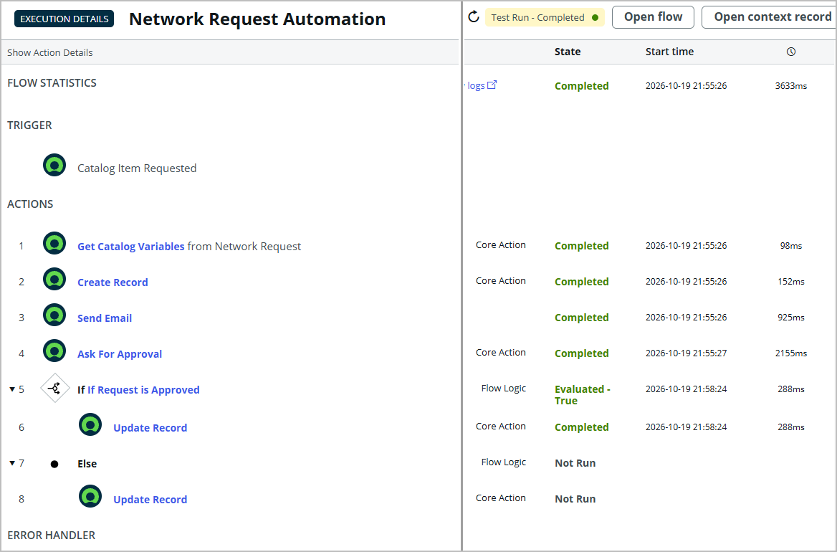
Screenshot 7: Flow execution details — Test Run Completed; Catalog Item Requested; steps 1–6 Completed; 'If Request is Approved' Evaluated — True; Else Not Run (empty middle columns removed)
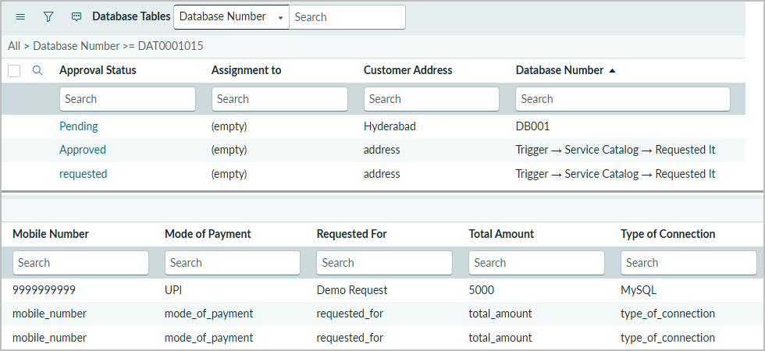
Screenshot 8: Database Tables list — Approved and requested records created by the flow (columns shown in two parts)
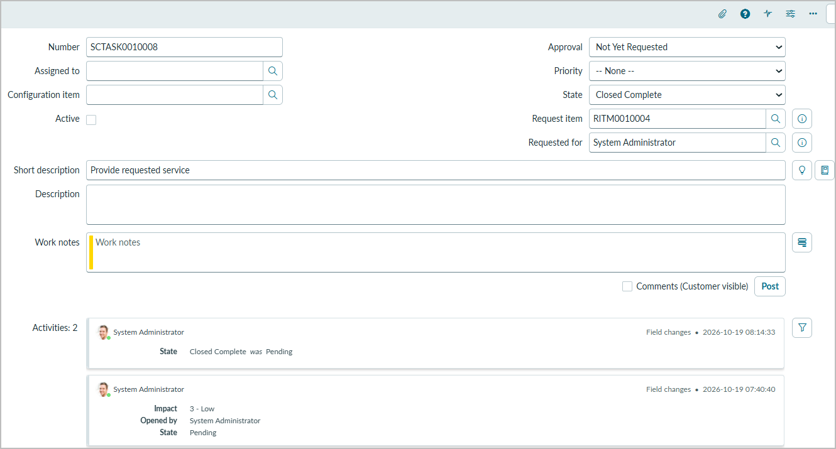
Screenshot 9: Catalog task SCTASK0010008 — State Closed Complete; Request item RITM0010004
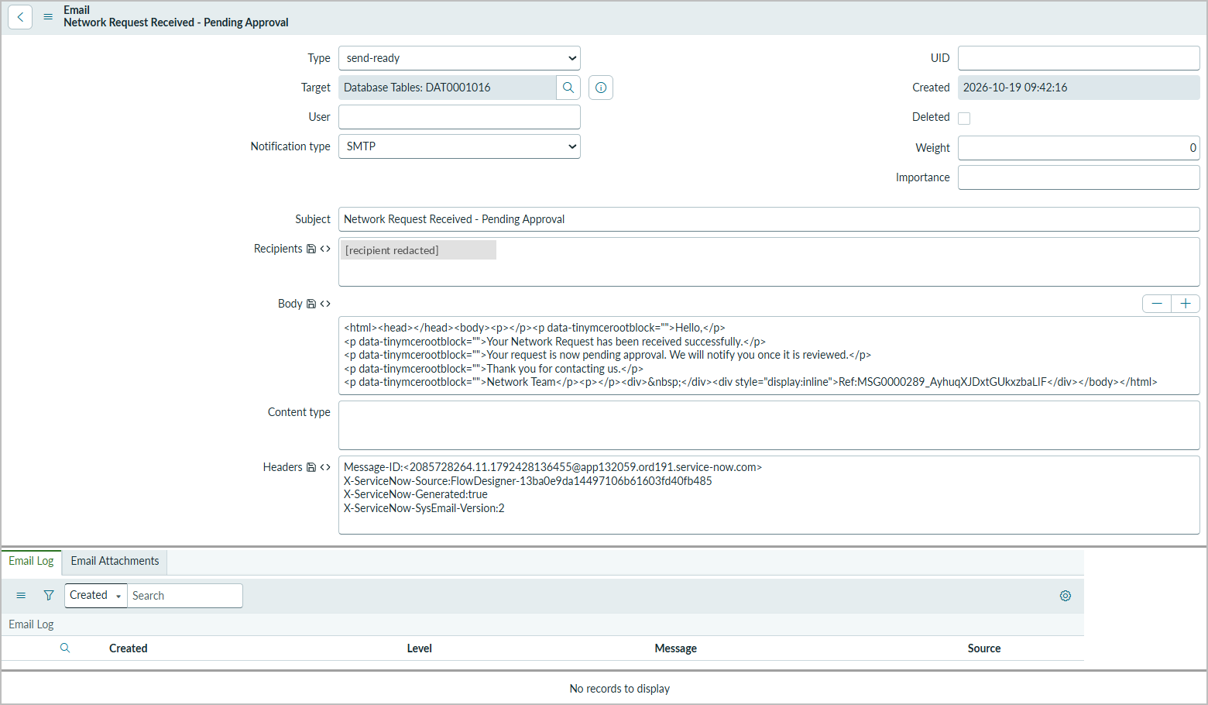
Screenshot 10: Email record 'Network Request Received - Pending Approval' — Type send-ready, Target DAT0001016, source Flow Designer; Email Log empty (recipient redacted)
Screenshot evidence index
No. | Shows | Location | Supports
1 | Catalog item availability; submitted requests | FSD 9 | TC-01, TC-02
2 | UI Policy behaviour (New) | FSD 9 | TC-04
3 | UI Policy behaviour (Existing); variables | FSD 9 | TC-01, TC-03, TC-18
4 | UI Policy configuration | FSD 3 | TC-03, TC-20
5 | Custom table structure | FSD 3 | TC-21
6 | Flow configuration | FSD 3 | TC-07, TC-08
7 | Flow execution evidence | FSD 11 | TC-07, TC-08, TC-12, TC-13, TC-14, TC-15, PT-02
8 | Database records; approval status; mapping defect | FSD 11 | TC-09, TC-14
9 | Catalog task closure | FSD 11 | TC-17
10 | Notification record | FSD 11 | TC-10, TC-11

Project demo (Drive folder): https://drive.google.com/drive/folders/1PAaBuybnLuN8JptoJ27fXBuDrTUFdcjM?usp=sharing
GitHub repository: https://github.com/pavan-kalyan-pk-2646/servicenow-network-request-automation.git
On 2026-10-20 the GitHub repository was publicly reachable and contained only README.md; the contents of the demo Drive folder could not be viewed by the documentation author and are not verified here.

12. Known Issues
- The Create Record action stores variable names instead of the submitted values, so the Database Tables records do not yet hold the real request data (BG-03).
- External email delivery is not verified: the email record remains send-ready, the Email Log is empty, and no active SMTP account is configured (BG-02).
- Phone Number in the Requester Information variable set did not populate for the System Administrator account (BG-01).
- The rejected (Else) branch has not been tested; in the documented test run it was Not Run.
- No ACLs are defined for u_database_table, and validation, access-control and load testing have not been performed (BG-04).
- Approval Status is a String field with inconsistent values (BG-05).
- The documented execution is a Flow Designer test run. The references REQ0010004 / RITM0010004 / SCTASK0010008, DAT0001016 (email target) and the test run come from different activities on 2026-10-19.
- Workflow Studio shows the flow as Active with status 'Draft', so unpublished changes may exist; the published version should be confirmed.
- The solution runs on a Personal Developer Instance in the Global scope; it has not been deployed to production.
Create Record mapping review (defect BG-03)
Defect found. Step 2 completed in the test run, but the flow-created records in Screenshot 8 hold the literal variable names (address, mobile_number, type_of_connection, requested_for, mode_of_payment, total_amount) instead of the values entered on the form. Database Number holds the text 'Trigger → Service Catalog → Requested It…'. This matches field values that were entered as plain text instead of as data pills. The variable names and column names below are taken from Screenshots 5 (table columns), 6 (data pills) and 8 (stored values).
Table 5: Create Record mapping — observed values and recommended correction
u_database_table column | Value stored (observed) | Recommended mapping (data pill)
Customer Address | address | 1 - Get Catalog Variables → address
Mobile Number | mobile_number | 1 - Get Catalog Variables → mobile_number
Type of Connection | type_of_connection | 1 - Get Catalog Variables → type_of_connection (Choice)
Requested For | requested_for | 1 - Get Catalog Variables → requested_for
Mode of Payment | mode_of_payment | 1 - Get Catalog Variables → mode_of_payment (Choice)
Total Amount | total_amount | 1 - Get Catalog Variables → total_amount
Database Number | Trigger → Service Catalog → Requested It… (text) | Intended source not documented. If it should hold the request reference: Trigger - Service Catalog → Requested Item Record → Number
Approval Status | Approved / requested | Set one consistent initial value (e.g. Requested); Ask For Approval writes the approval state to this field

- enter_your_existing_id and email have no matching column in u_database_table, so they are not stored.
- Choice pills (type_of_connection, mode_of_payment) pass the choice value, which may differ from the label shown on the form; check the stored values after the fix.
Recommended correction (not yet applied or retested):
1. Open Workflow Studio → Network Request Automation → Edit flow.
2. Open step 2 'Create Database Tables Record'.
3. For each field in the table above, clear the typed text and drag the matching data pill from the Data panel (section '1 - Get Catalog Variables'), so the field shows a pill, not plain text.
4. Decide what Database Number should contain and map it accordingly.
5. Save, then Activate / publish the flow (the status bar currently shows 'Status: Draft').
6. Retest: order Network Request with distinct test values, open the new Database Tables record and confirm each field matches the form. Then update TC-09 and BG-03.
Until this retest is done, the Database Tables records must not be treated as holding correct request data.

13. Future Enhancements
- Fix the Create Record mapping with data pills from Get Catalog Variables and retest (BG-03).
- Configure and validate an SMTP account so notifications are delivered, then retest delivery.
- Add approval and rejection outcome emails to the requester.
- Test the rejected (Else) branch and add flow error handling.
- Add client-side validation for mobile number format and make the existing ID mandatory for Existing connections.
- Define ACLs on the Database Tables table and test with non-admin users.
- Convert Approval Status to a Choice field with consistent values.
- Route catalog tasks to a Network assignment group and add SLAs for turnaround time.
- Build reports and a dashboard of requests by status, connection type and payment mode.
- Package the configuration as a scoped application with an update set for repeatable deployment.

Appendix — Approval Request relationship script
(function refineQuery(current, parent) {
current.addQuery('source_table', parent.getTableName());
current.addQuery('document_id', parent.sys_id);
})(current, parent);

